Hamilton Performing Arts Centre

Note: Information on this page is current as at 26 February 2021. It is subject to change at any time, for any reason.

A CovidSafe Venue:
To ensure a safe and comfortable environment for everyone, we’ve made some changes to the way we operate. This includes the introduction of a number of measures:
- Patrons aged 12 and over attending performances are recommended but not required to wear a face mask at all times while inside our foyers and theatres, including during the performance.
- QR code check-in – all patrons and their guests must check-in upon entry.
- Regular cleaning of high-traffic and high-touch areas with hospital-grade disinfectant.
- Hand sanitiser stations in all paths of travel, frequently accessed areas and near bathroom facilities.
- Floor markings & safe queues to when accessing the box office, bar or toilets
We are closely following all Victorian Government health guidelines and will continue to update our procedures as necessary. All Hamilton Performing Arts Centre shows whether at the venue or at other supported venues will comply with the guidelines.

Seeing a show?
We’ve made a number of changes to our booking process and seating plans to help keep you safe:
- Hamilton Performing Arts Centre and Hamilton Cinema are currently operating at reduced capacity (up to 75%).
- Our seating map is designed in line with the current Government regulations, but we do not guarantee there will be a gap or seat between you and others. Seating allocations may change at any time and we do not guarantee the seat you purchased is the seat you will be sitting in. For general admission performances our staff will direct you to where you’ll be seated.
- We encourage you to purchase your tickets in advance online or via the phone, but our box office is open if you wish to visit in person.
- Venue foyers and doors will open earlier than normal, and some shows will have modified intervals.
- Refreshments will be available for purchase from our foyer bar, and should be consumed while seated in the auditorium. All non-alcoholic drinks (unless advised otherwise) can be taken into the theatre for all performances.
- Where possible, please refrain from booking tickets for other people. Encourage them to book themselves and their own group.

When to stay home.
For the safety and wellbeing of everyone, you must not visit the Hamilton Performing Arts Centre if:
- You feel unwell or if you are displaying any of the COVID-19 symptoms as identified by Victorian Department of Health;
- You have tested positive for COVID-19 in the last 14 days or are awaiting the results of a COVID-19 test;
- You are required to self-isolate; you have been in contact with a confirmed case of COVID-19 in the last 14 days before your intended date of visit to the venue;
- You have visited a “positive COVID-19 case location” (as outlined by the Victorian Government in the last 14 days before your intended date of visit).
If one of the above applies to you, contact us for a full refund of your tickets. This should be done at least 1 hour prior to the performance time if possible.

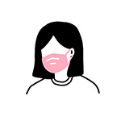

Masks are recommended, but not required.
Patrons aged 12 and over attending the venue are recommended, but not required to wear a face mask while inside our foyer and theatre, including during the performance.
Some members of the community may have issues with wearing masks due to health conditions. We ask that you be respectful to others as reasons for not wearing a mask are not always obvious. (Mask rules are subject to change, and will be communicated at the entry points).
Note: mask rules are subject to change should the public health rules change at any time.

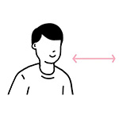
Get together, but keep apart.
As you move around the venue, practise physical distancing (1.5 metres whenever possible) and follow the guidance provided by our staff and signage.
Our venues are currently operating at a reduced capacity and you must always take your allocated seat.

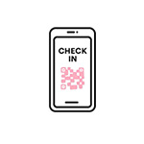
Follow the signs, and sign-ins.
Follow the entry and exit points, check in procedures, and physically distance in all queues.
On arrival at the venue, you and your guests will be required to sign-in with a QR code. If you are unable to sign in with the QR code, a staff member will be present to direct you to a manual sign-in point.
If you refuse to sign in you will be required to leave the venue, without refund or recourse.

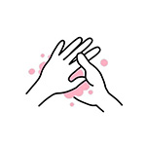
Keep clean.
Practise good hygiene by washing your hands regularly with soap, using hand sanitiser, covering sneezes and coughs and disposing of tissues promptly.
Hand sanitiser is available in many locations throughout the venue, and soap is available in all bathrooms.

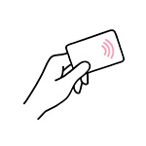
Pay with card.
Contactless payment methods are strongly encouraged, as it keeps service moving quickly.
Cash will be accepted, but may take a little longer to process to ensure are staff remain safe & sanitised.

COVID-19 Updates:
For further information regarding the Coronavirus response, please visit:
Victorian Department of Health and Human Services: Click Here

